How to Add Clients to the TC Agendas in Central Reach: For Providers
- First, accept the ‘invite’ to be connected to your region(s)/team(s) contact in CR (this step will need to be completed 1 time only).
- Click on the Contacts icon and then choose ‘Invite Requests’
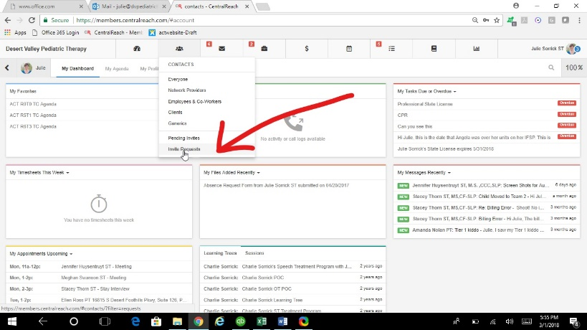
- Locate your region/team contact (you may have to use the search bar if you have many) then click ‘Accept’.
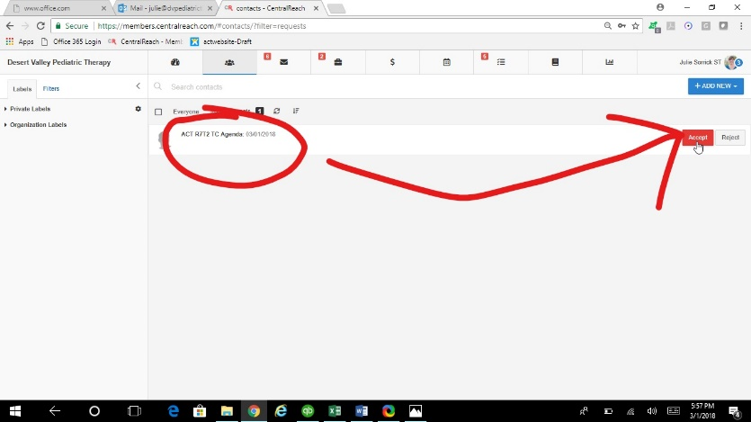
- Ensure your Region(s)/Team(s) are set as a ‘Favorite’ in your CR account (this step will need to be completed 1 time only).
- Go To Contacts
- Search for your region/team contacts
- Open the contact
- Click the start next to the place for the profile picture
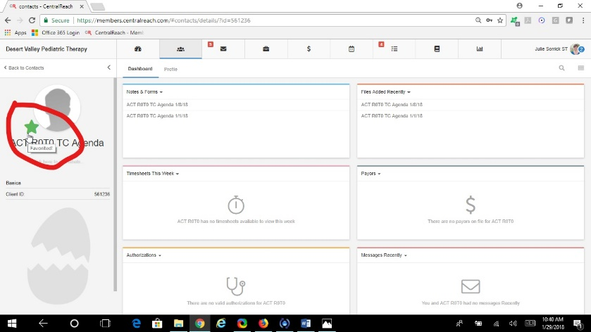
TWO EASY WAYS TO ACCESS AND ADD TO YOUR AGENDA
OPTION #1:
- When you login, your favorites will be on your dashboard. Click the Region/Team TC Agenda in your favorites.
- Locate Notes & Forms in your widgets and click on the agenda you wish to add to (each agenda is ONE week).
- You will add clients to the sections called ‘Other Agenda Additions 1-5’ or ‘Other Agenda Additions 6-10.’
- Add ALL requested information for each client.
- Click SAVE at the bottom of the page. NEVER CLICK LOCK AND SAVE!!

OPTION #2:
- Go to your files module in CR
- Locate the agenda you want to add to (text search by region/team, date of agenda, or words in the title) and click on the title to open it.
- Click on ‘Note & Form’ at the top of the screen.
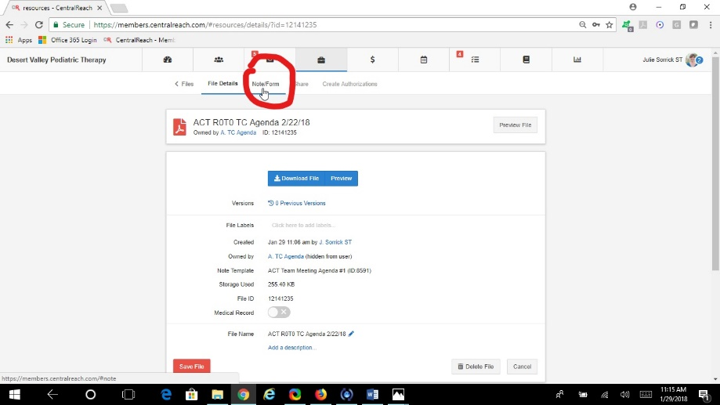
- You will add clients to the sections called ‘Other Agenda Additions 1-5’ or ‘Other Agenda Additions 6-10.’
- Add ALL requested information for each client.
- Click SAVE at the bottom of the page. NEVER CLICK LOCK AND SAVE!!

