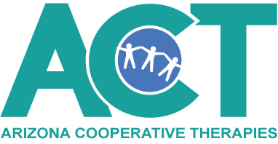
June 19, 2020
Dear Families & Caregivers,
Thank you for your support and understanding as we, as a nation and community, responded to the unexpected pandemic of COVID-19 in March.
As of May 8, 2020, Arizona Early Intervention Program (AzEIP) continues to support early intervention programs in their use of alternative methods to serve children and families. ACT will continue to engage with families, process all new referrals, provide ongoing support and services, and conduct transition activities utilizing tele-intervention through ZOOM.
Although Arizona’s stay-at-home orders are gradually being lifted, AzEIP will not be resuming required in-person home or community visits at this time. Decisions made by AzEIP in response to COVID-19 were guided by our federal and state governing bodies and public health guidelines, which include the Office of Special Education Programs (OSEP), the Office of Special Education and Rehabilitative Services (OSERS), Executive Order directives from Arizona’s Governor, Arizona Department of Health Services (ADHS), and the Centers for Disease Control and Prevention (CDC). AzEIP will also take all governing bodies directives into account when making any future decisions on service delivery options and requirements.
We encourage families and caregivers to regularly monitor information from the AzEIP: https://des.az.gov/services/disabilities/early-intervention/azeip-response-covid-19
Thank you for your continued support and positivity as we strive to do what is best for all our families and providers during these challenging times.
Caroline Oglesby
ACT Program Director
602-547-1111

