Go to AZEIP’s website to access the iTEAMS link.
https://www.azdes.gov/main.aspx?menu=98&id=3026

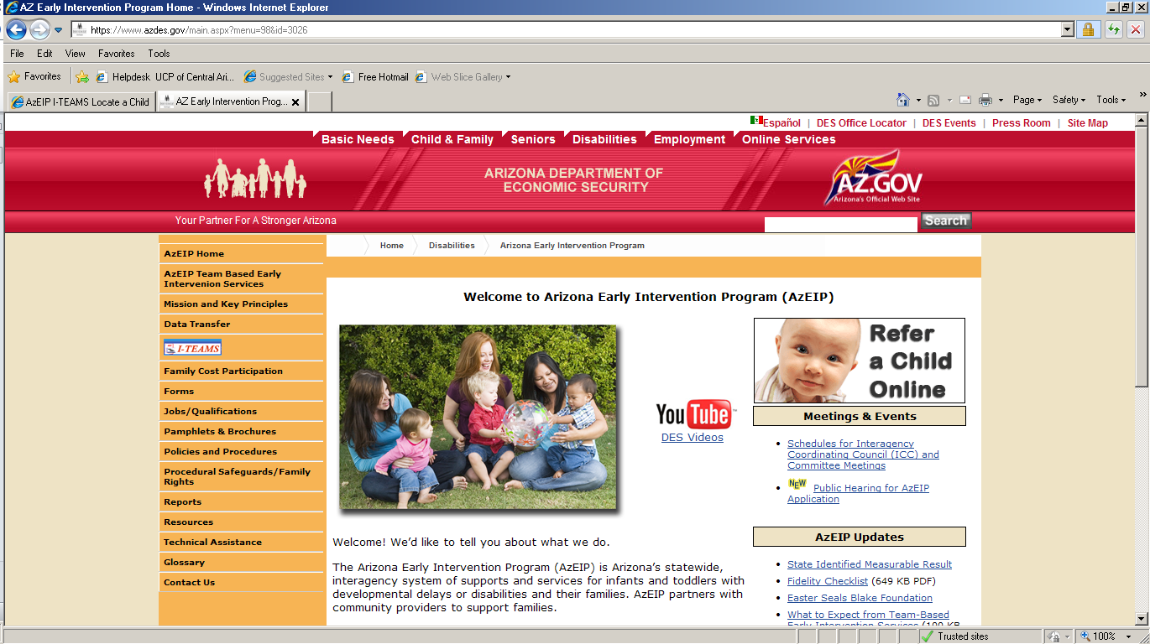

Use the top link to enter iTEAMS.
https://www.azdes.gov/main.aspx?menu=98&id=10848

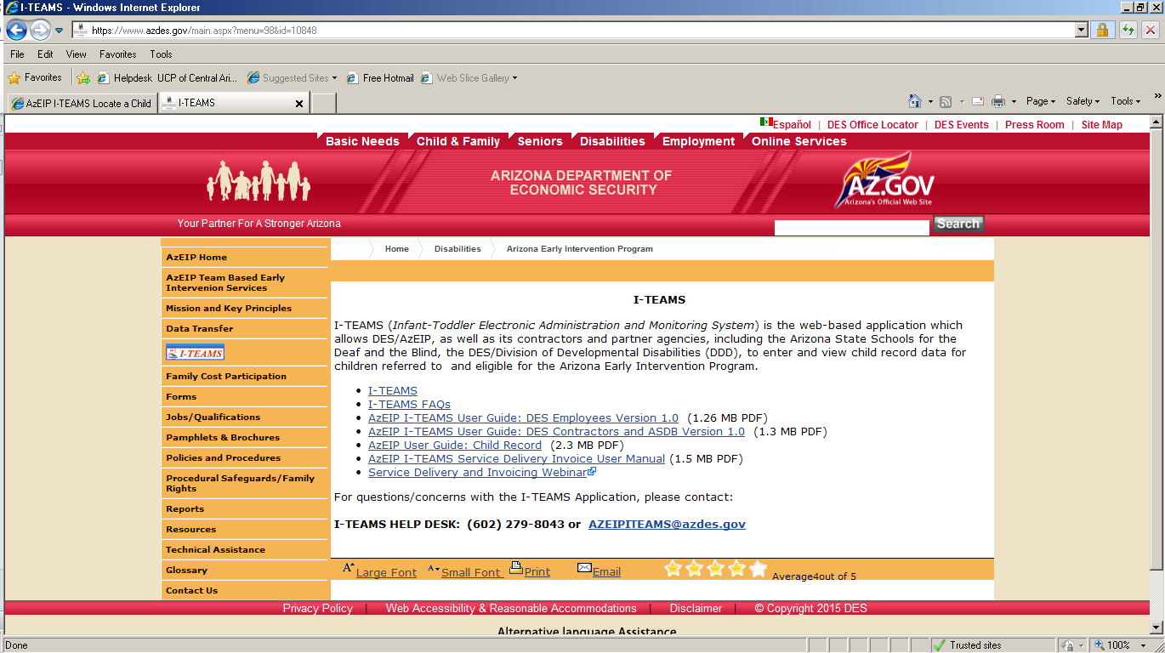

This is the front page of iTEAMS. Click Agree (this will happen every time). To make this easier to get to, go to file on the top left and pick “send” then chose send shortcut to desktop. This will give you an icon on your desk top. Example: https://extranet.azdes.gov/AzEIP/AzEIP_ITEAMS/Account/Login.aspx?ReturnUrl=%2fAZEIP%2fAZEIP_ITEAMS%2fAccount%2fLogout.aspx

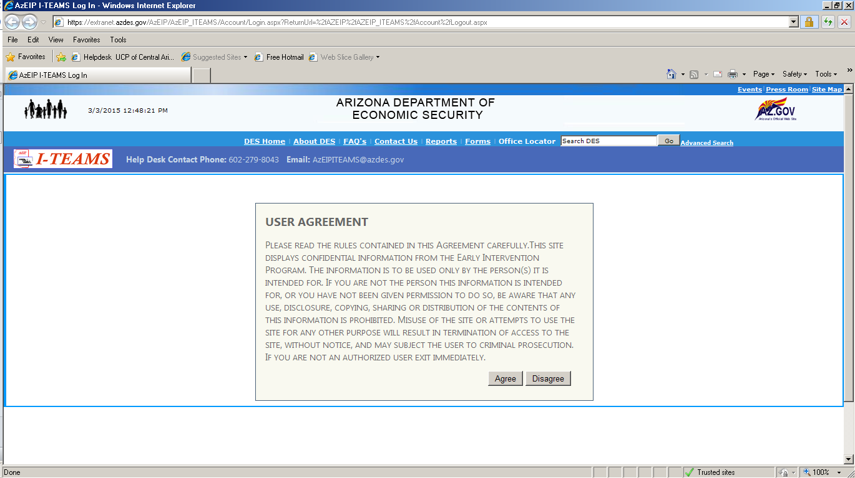

Enter your assigned user name and password and click Log In.

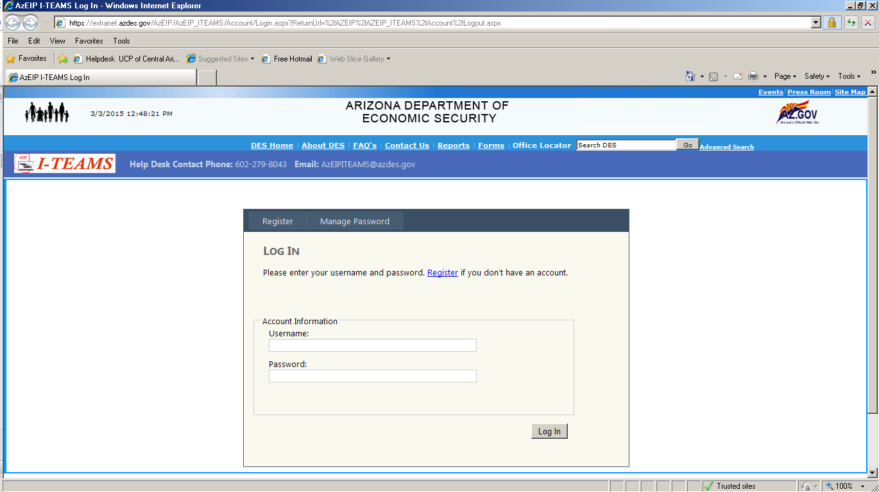

Once here you can look up a child by the “locate child”
link on the left side of the screen.

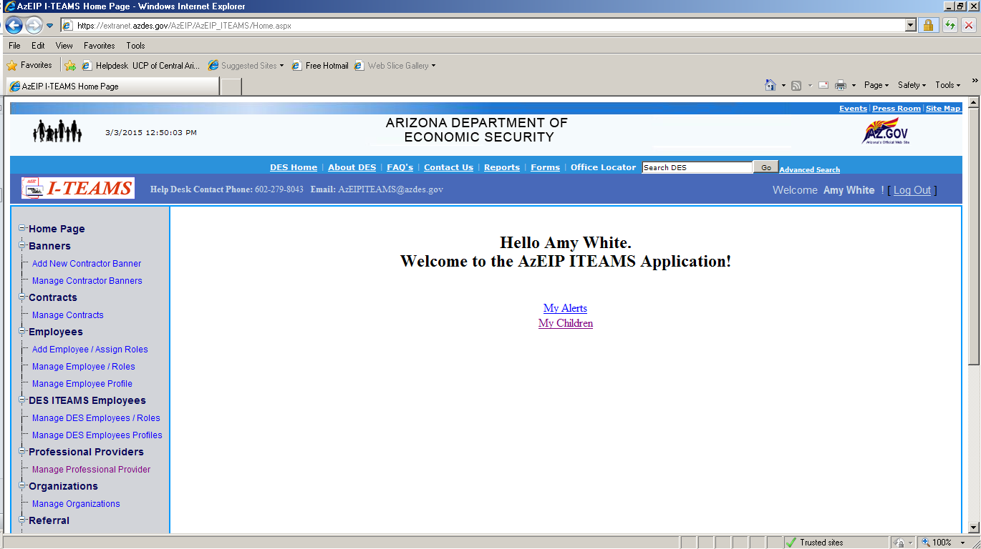

You can search by iTEAMS number, child’s last name, first name, etc. It can be a combo of more than one thing as well.

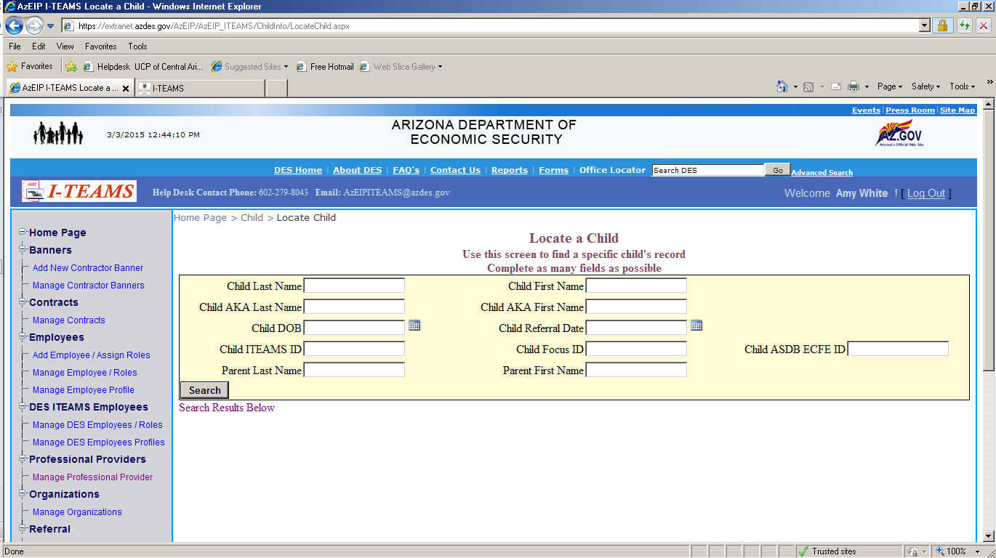

Once you find the child you are searching for, click on the “select” button and it will take you into the screen below.

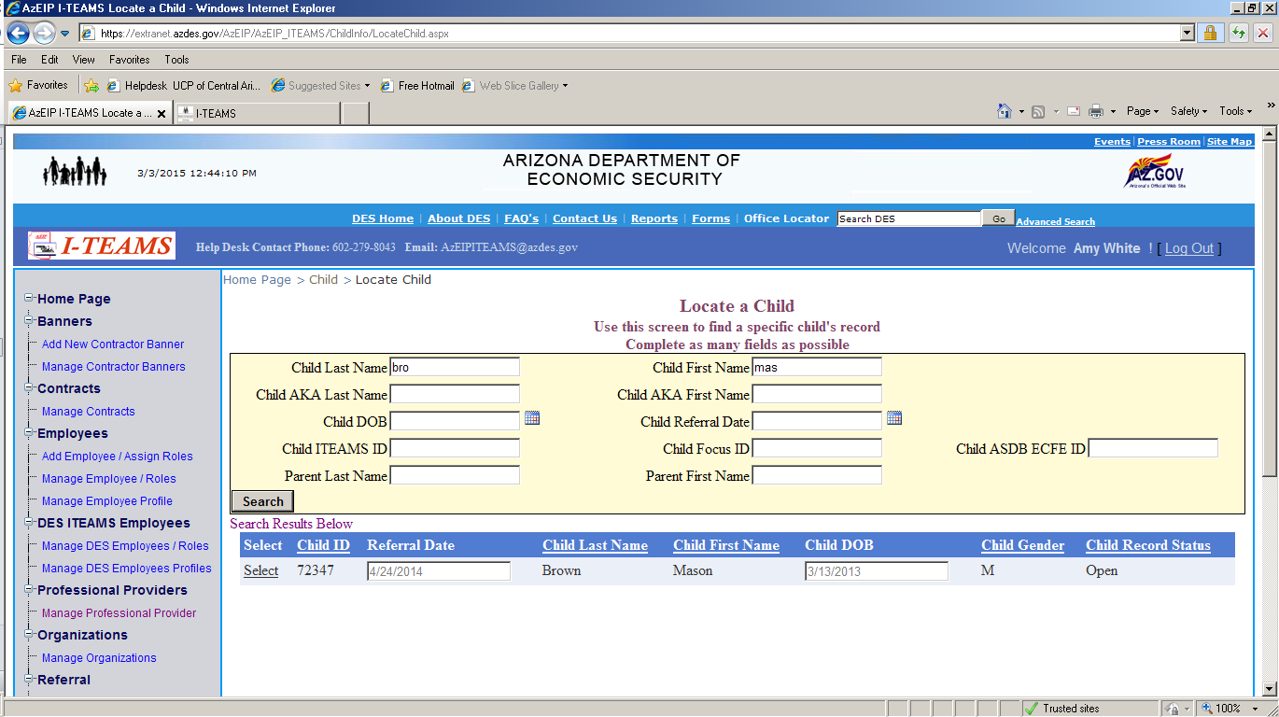

After you click Select, it will bring you to this page, click “Child Demographics” to enter the child’s record.

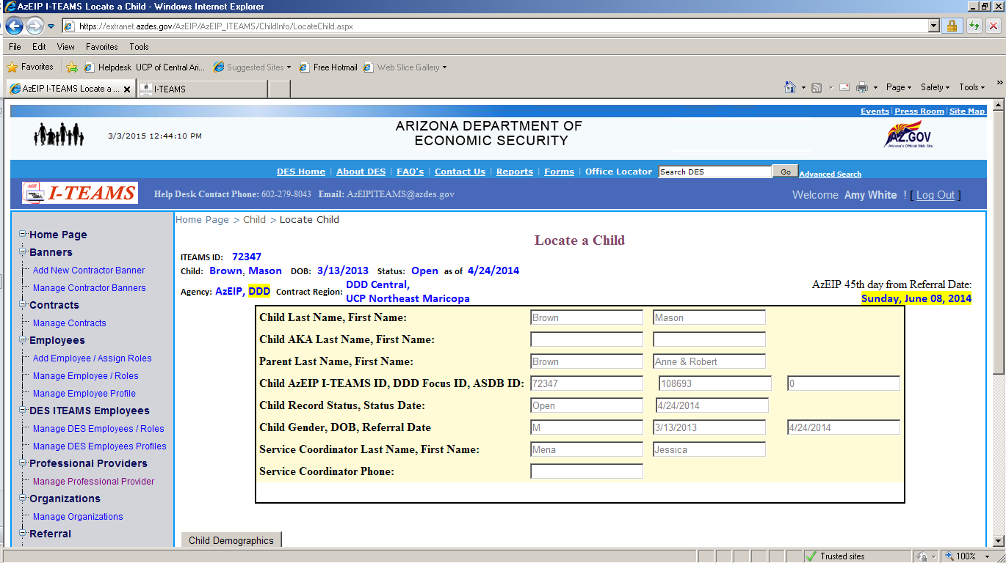

This is the child’s demographic page. If you scroll down you will see different options for alternate screens to go into.

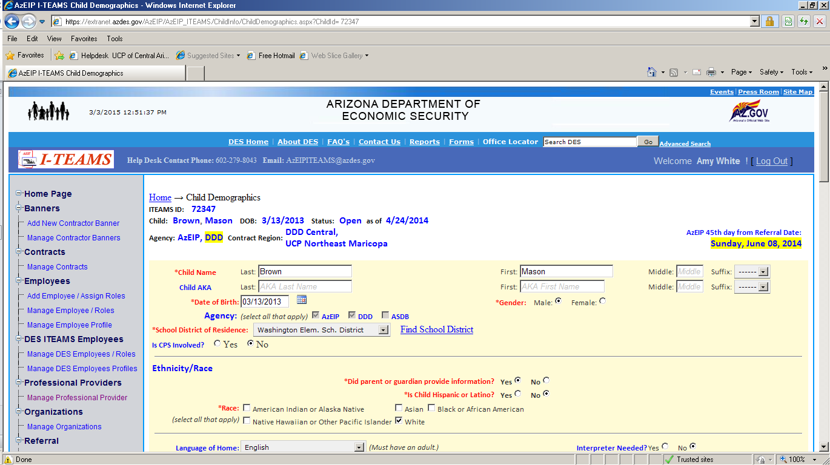

Click on “Service Delivery” to enter your Daily Notes.

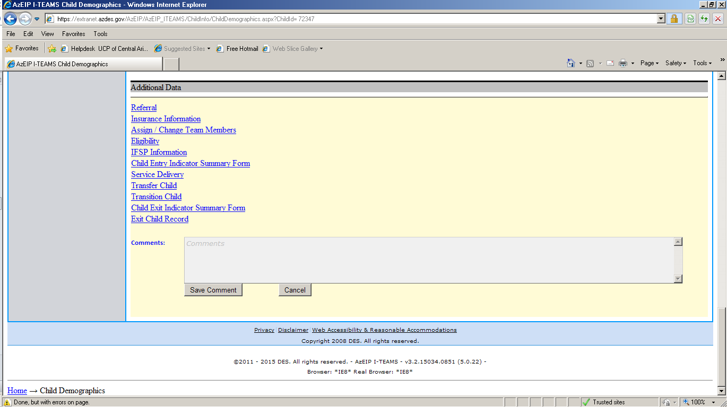

You will first pick the date of the Entry or Session.
Please note it defaults to today’s date.

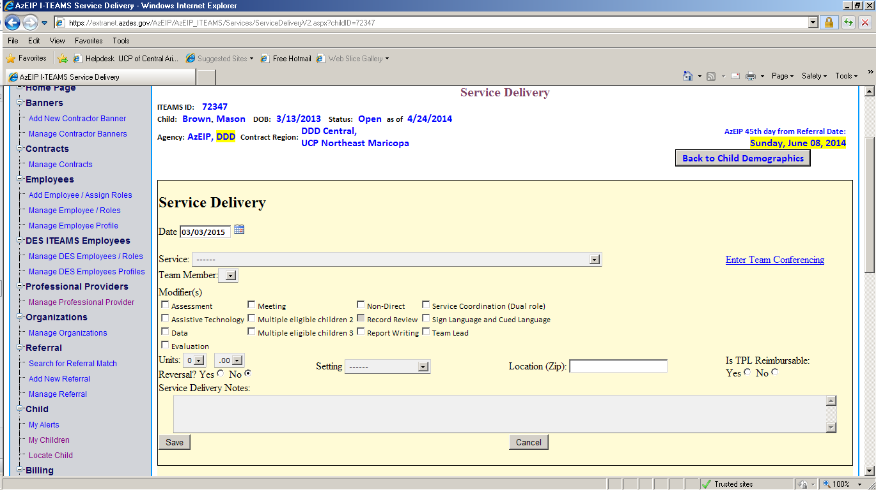

Then you will Pick the service.

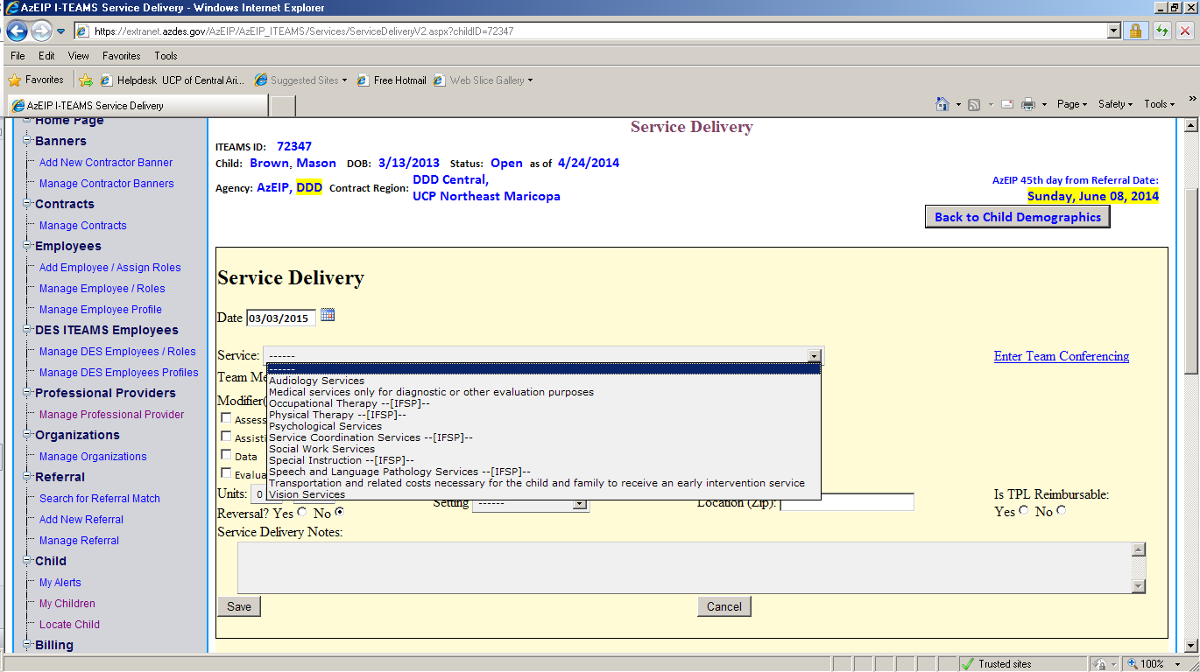

Note:
If the Service provided is during the Initial Planning Process, the system will log it as “Not an IFSP Service” this is fine.

If the service provided is connected to an established IFSP, you will see there is an [IFSP] label next to the services. These means the service is on the IFSP and CAN be billed.

If the service you are hoping to enter a daily note for does not have this then there is a chance it will not be a valid bill to AZEIP or the IFSP has not been updated in iTEAMS.

Then you will be able to pick the Team Member.

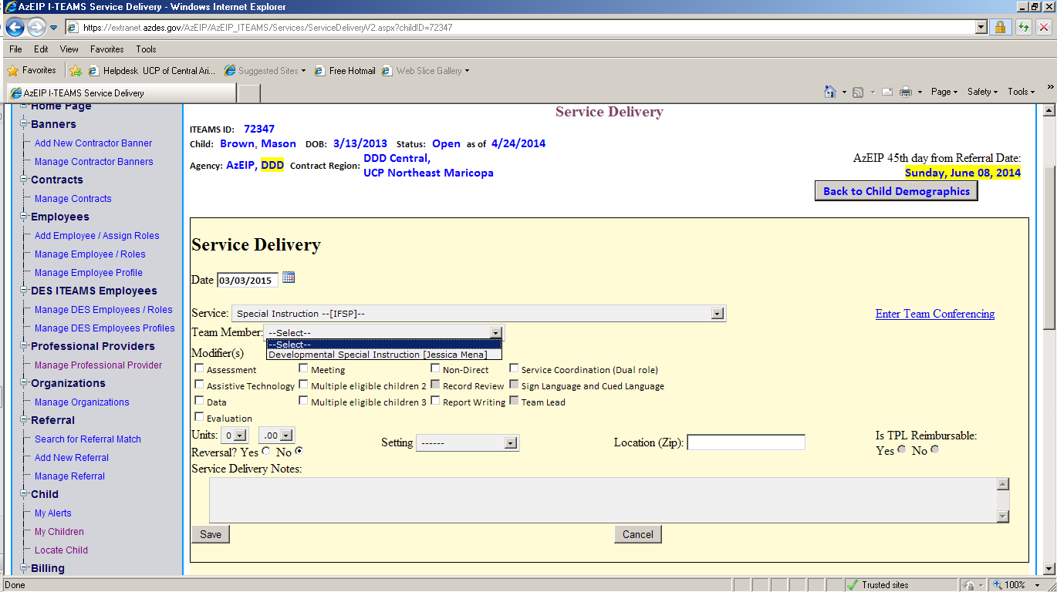

Note:
If you are entering Service Coordination, it will bring up all team members (as AZEIP allows Dual Role, just pick your name).
If you are considered a core team member, it will only offer the name of the provider connected to this service and child.

Next you will pick the modifier(s) connected with the Service Provided. There is a chance you may need to click more than one. If they are grayed out they are not considered an option for you.

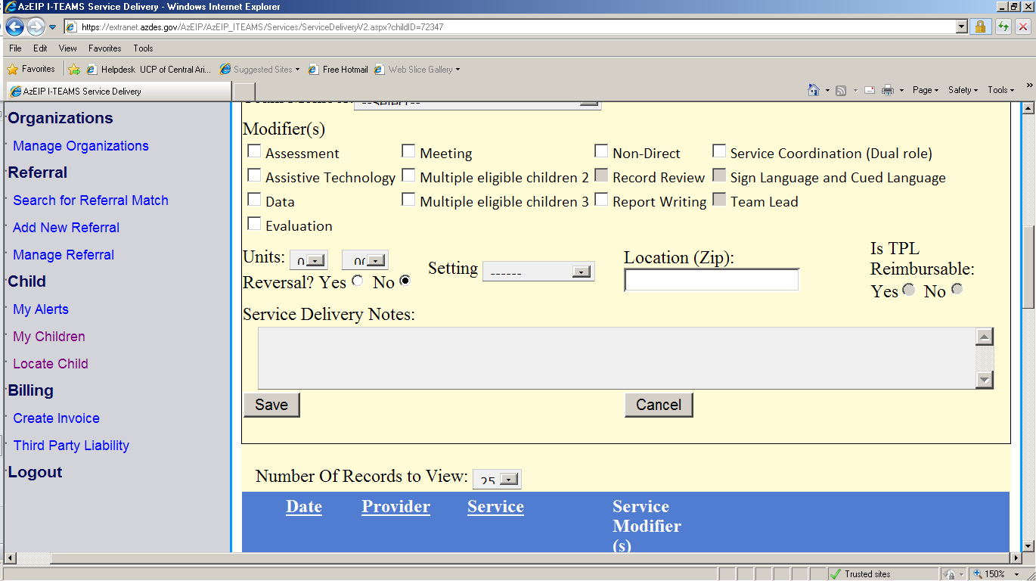
You will enter your units of service. Whole numbers on in the first column and .25 increments are in the second column.

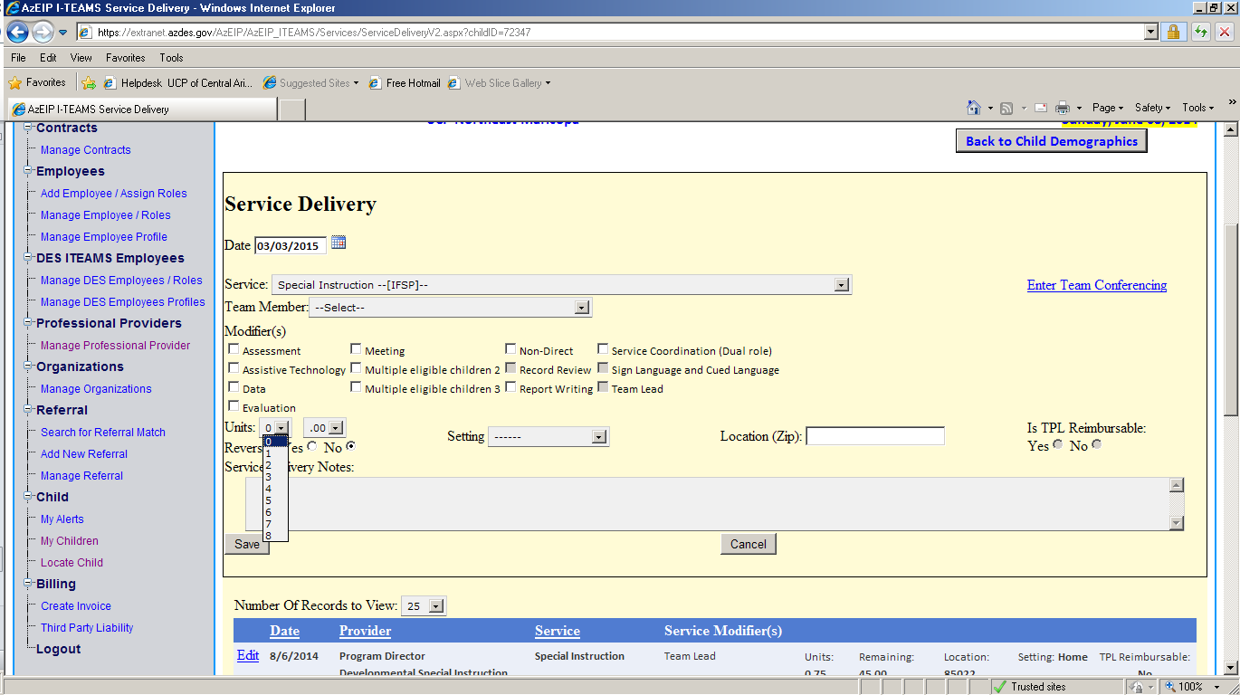

Enter your Delivery notes and then click “Save”

