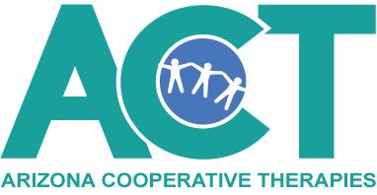
Audit Tools in Central Reach

- Pull up individual child’s record in Central Reach
- Go to Notes and Forms Widget
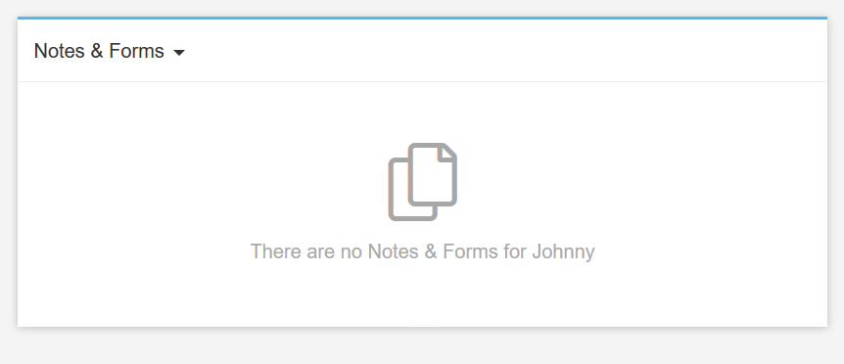
- Hover curser over widget until Create Note appears. Click on Create Note button
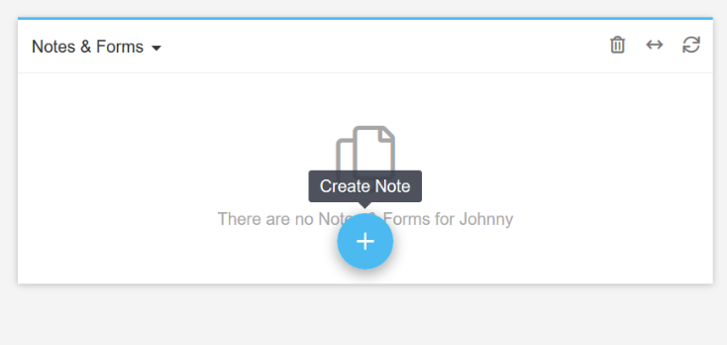
- Click on Add New
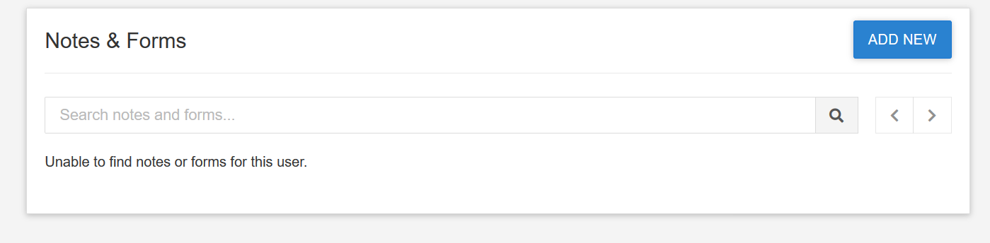

- Click on ACT Child Record Audit Tool
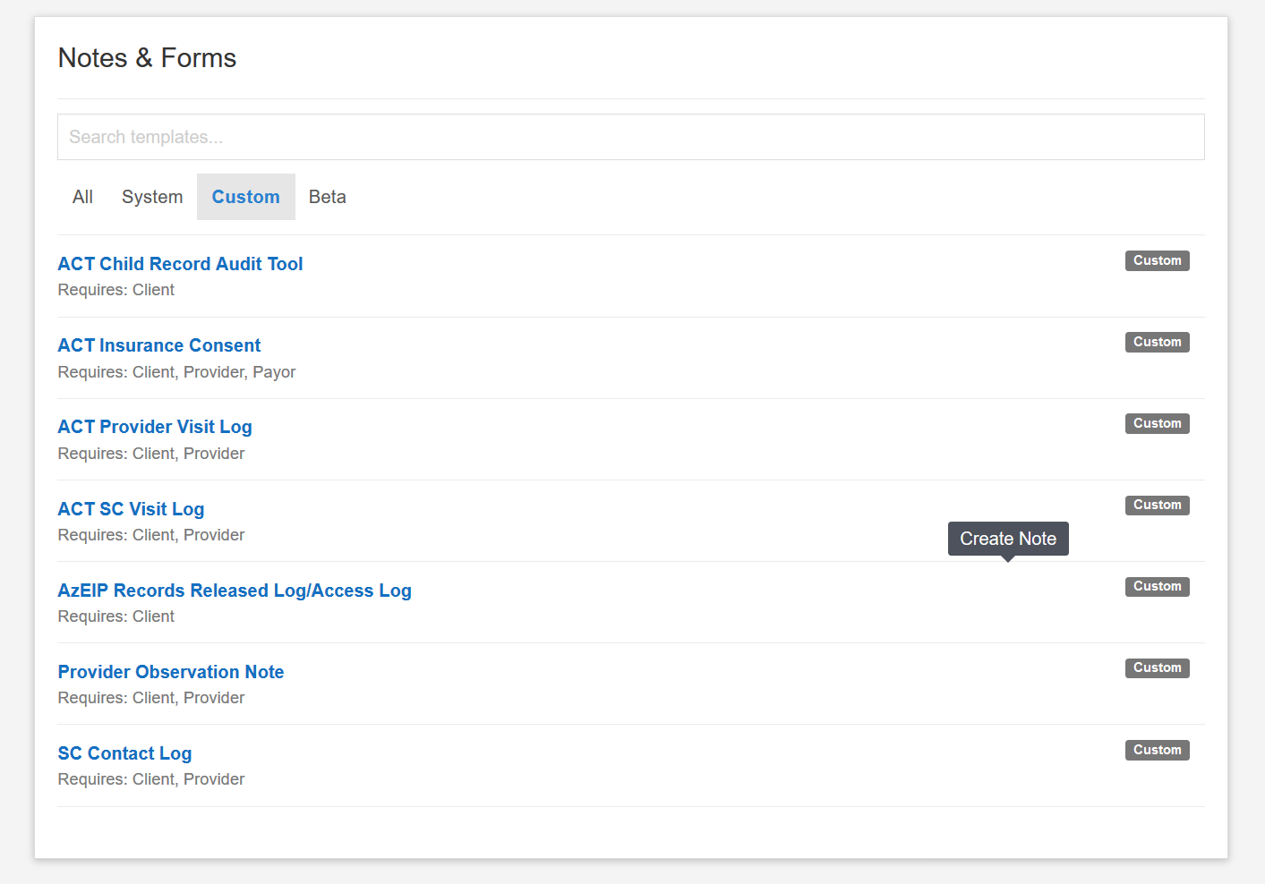

- The document title will appear, however, it will not autogenerate the region/team. Add region/team to Title

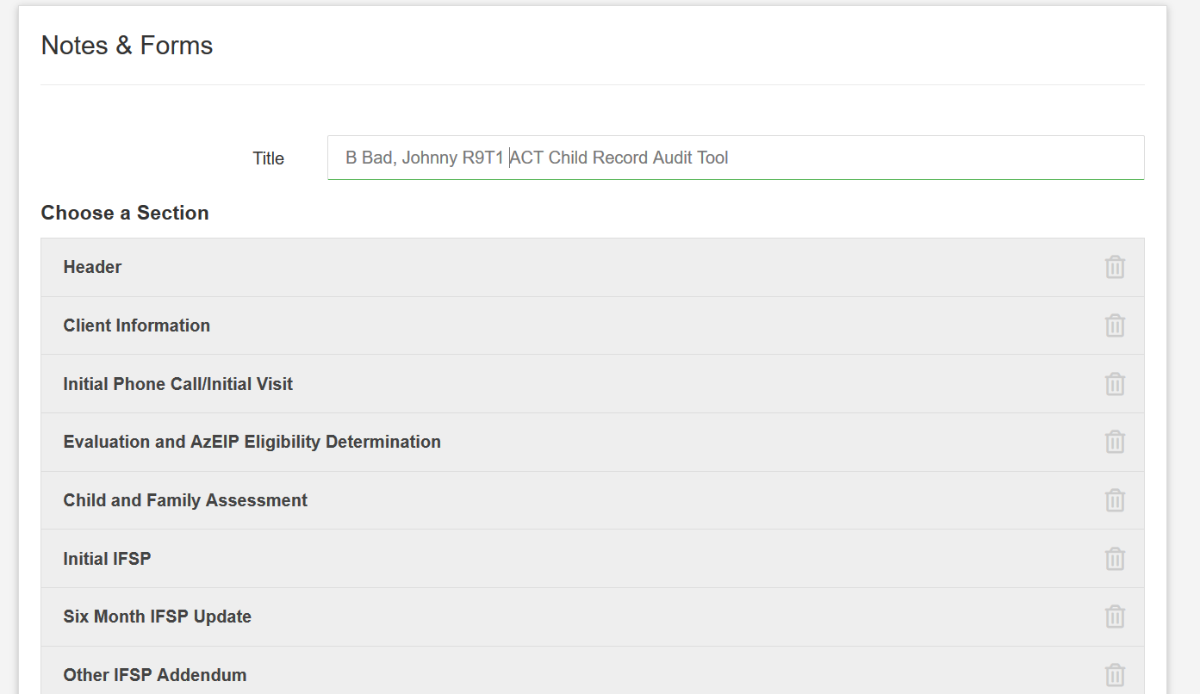

- Click on Client Information section and add I-Teams ID and Service Coordinator
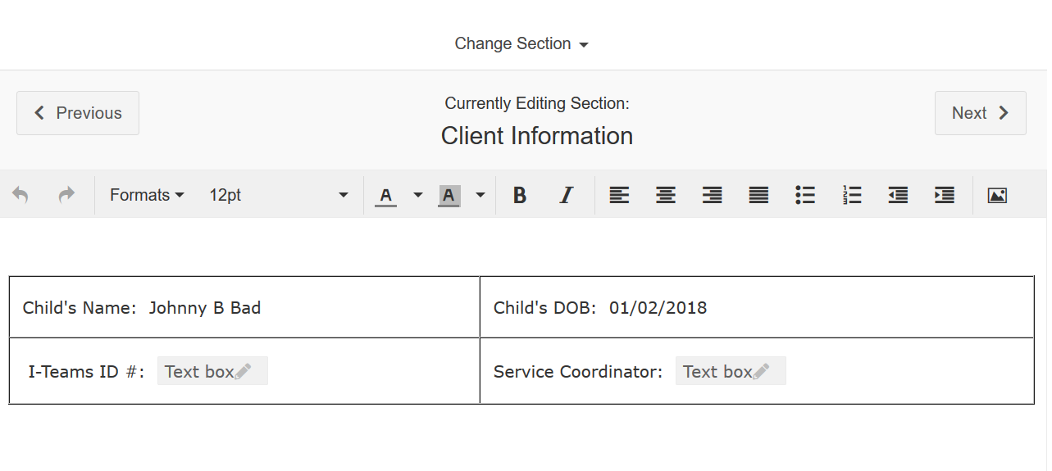
- Click Next to move to the Initial Phone Call/Initial Visit section or Click on Change Section to move to the audit tool that is being completed.

- Click on Save when all audit tools are completed at that time.
  - Do not click on Save and Lock unless you do not want this to be a running record. This will not allow any further audits to be added to this file and another one will need to be created for subsequent audits for this child.

- Once Saved, this will add to files and any time you need to complete a new audit, click on it in the Notes and Form section
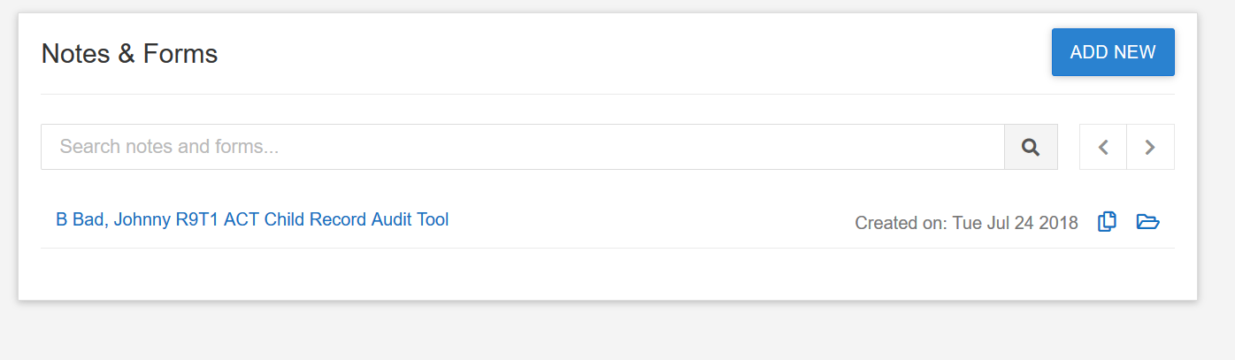

- Click on the file folder to the far right and it will open the document in files. Share with your region/team.
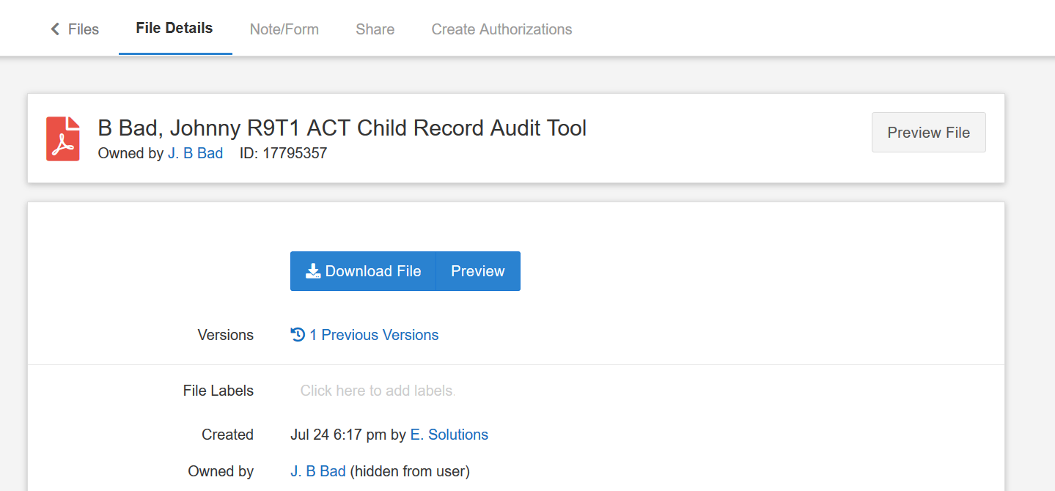

- Example of what you will see within the audit tools:
